**L3 - Launch AWS EC2 Ubuntu Instance and configure the Security Group - Inbound Rule:8080. Justify the usage of Inbound Rules**

**Step 1: Launch EC2 Instance**

1. **Sign in to AWS Console** 
   * **Go to AWS Management Console**
   * **Navigate to EC2 service**

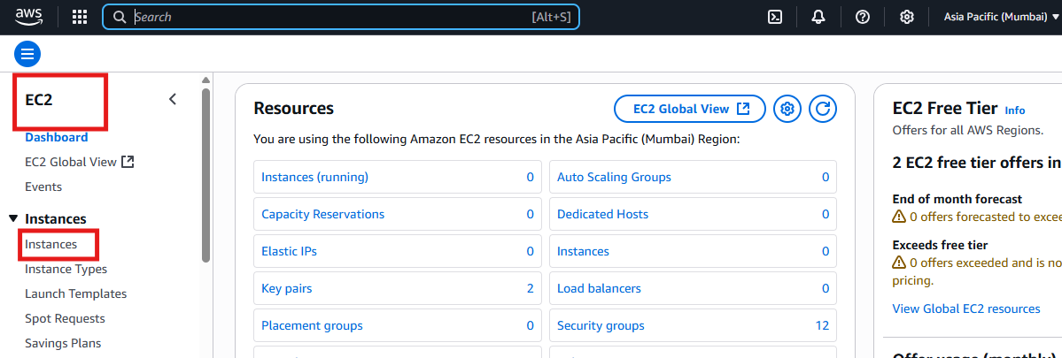

**2.Launch Instance**

* **Click "Launch Instance"**
* **Choose "Ubuntu Server"**
* **Select instance type (t2.micro for free tier)**
* **Choose key pair**

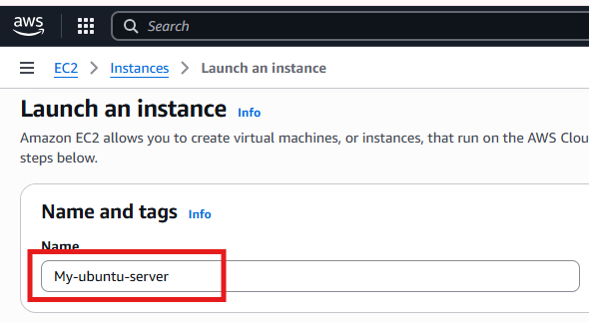

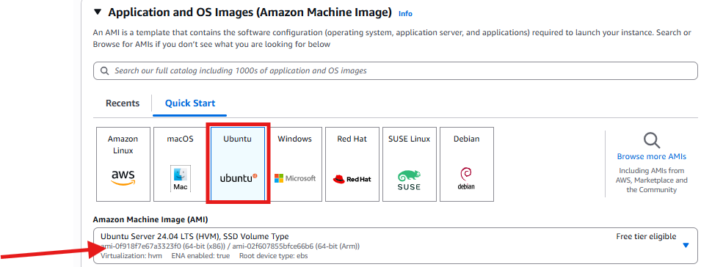 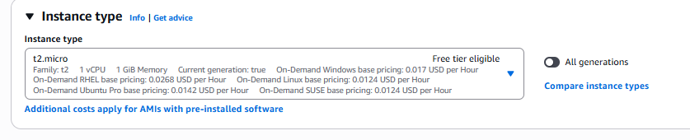

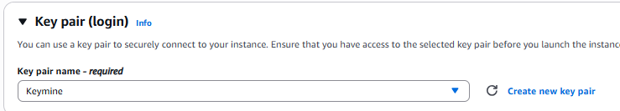

**3.Network Setting**

**Create a security group or select existing security group**

**Click on Allow SSH traffic from and Allow HTTP traffic from the Internet**

**Configure storage to be kept as default**

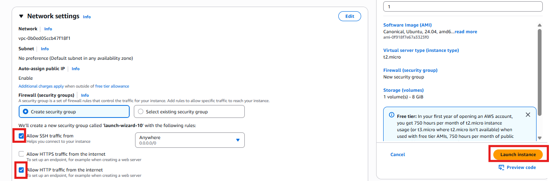

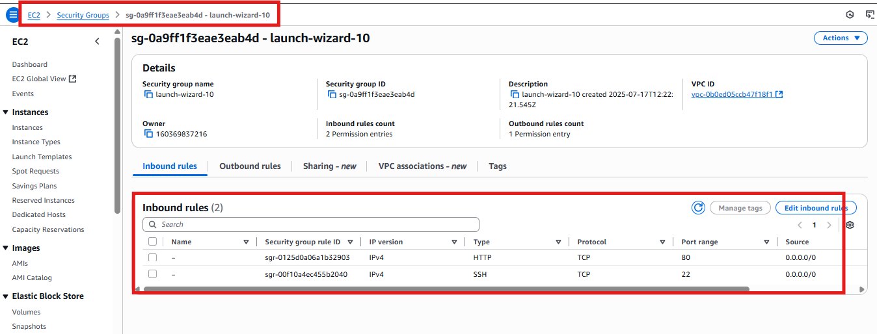

**Connected via SSH**

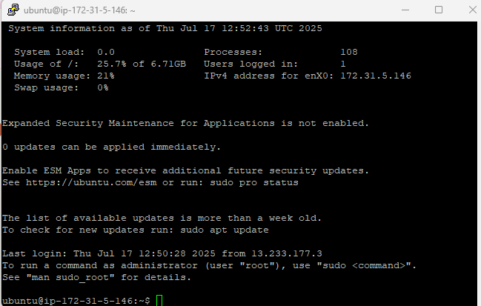

**Webinterface**

